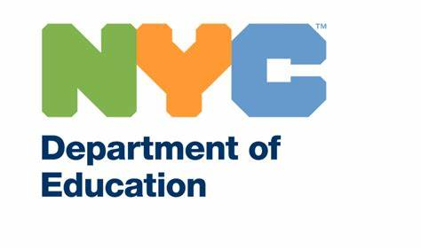

March 24, 2020

Dear PS 748 Community,
As you know, the health and safety of our students and staff is our top priority. Much has changed very rapidly with respect to COVID-19 in our school community and citywide. School buildings are now closed to students until April 20, 2020, and remote learning has begun for all students.
With respect to the PS 748 community, I am writing to inform you that a member of our school community has self-reported that they tested positive for COVID-19. A disinfection of the school building has been completed in accordance with New York State Department of Health guidelines. As a reminder, the DOE routinely conducts deep cleanings in your school.
Please also note that according to the NYC Department of Health, there is now widespread community transmission of COVID-19 in New York City, meaning the sources of new infections are unknown. Everyone in New York City should act as if they have been exposed to COVID-19. That means monitoring your health closely and staying home if you are sick. New Yorkers who are not sick should also stay home as much as possible and avoid all unnecessary social interactions.
What You Should Do
● Call your doctor if you have symptoms like coughing, shortness of breath, fever, or sore throat and tell your doctor that you may have been exposed to COVID-19. If you need help finding medical care, call 311.
● Educate yourself about COVID-19 through the NYC Health Department’s website at https://www1.nyc.gov/site/doh/health/health-topics/coronavirus.page and https://www1.nyc.gov/assets/doh/downloads/pdf/imm/coronavirus-factsheet.pdf
● Continue to practice general viral infection prevention measures including:
Wash your hands with soap and water often.
Cover your nose and mouth with a tissue or sleeve when sneezing or coughing.
Do not touch your face with unwashed hands.
Monitor your health more closely than usual for cold or flu symptoms.
Get your flu shot – it’s never too late.

Please visit schools.nyc.gov/coronavirus for important school-related guidance and nyc.gov/coronavirus at any time for critical updates, including ways to fight stigma and bias around the coronavirus. It’s important we come together and support one another during this time.
Nothing matters more than the health and safety of our staff and students, and we are committed to keeping our school community fully informed.
Please do not hesitate to reach out contact Superintendent Karina Costantino at KCostan@schools.nyc.gov with any questions.
Sincerely,
Ursula Annio, Founding Principal

